**Towers Test Cases:**

* **Placing Towers**
* Scenario: Selected a tower and dragged it on the map.
* Result (**EXPECTED**): A blue circule, showing the area of the tower projectiles, appears with the tower color being either green(can place) or red(can’t place).

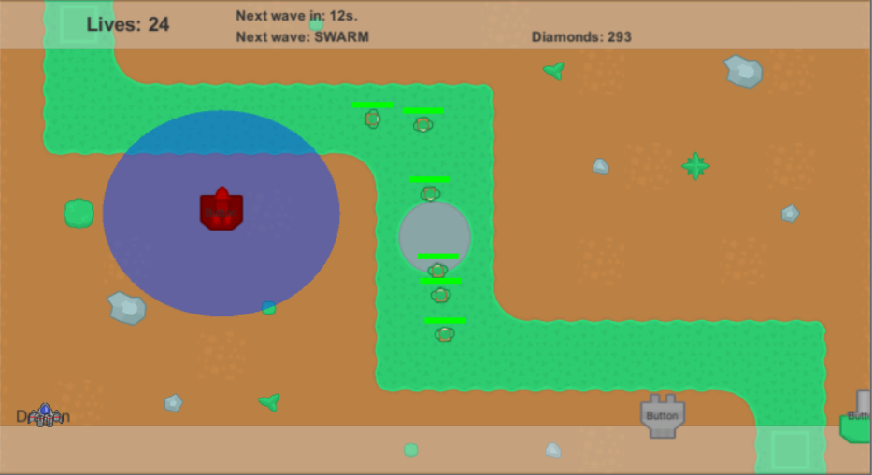

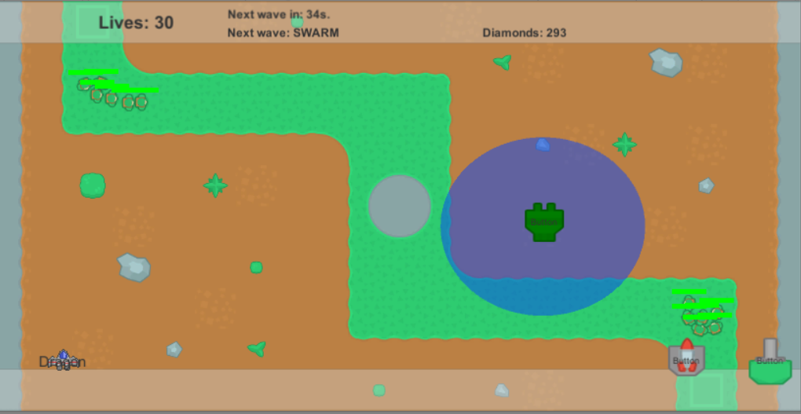

* **Basic Tower**
* Scenario: Selected basic towers (and played around with the projectile speed and damage) and dragged them on the map while enemies spawned.
* Result(**EXPECTED**): The towers shoot projectiles into all enemies(damaging them), except „Flying”.
* **AoE Tower**
* Scenario: Selected AoE towers (and played around with the projectile speed and damage) and dragged them on the map while enemies spawned.
* Result(**UNEXPECTED**): The tower shoots into all types of enemies, (INCLUDING „Flying”). The projectiles damage all enemy types, except „Flying”. Against „Flying”, the projectile doesn’t damage them, but it pushes the enemies either backward or towards the playes, depending on how the projectile collides with the enemies.

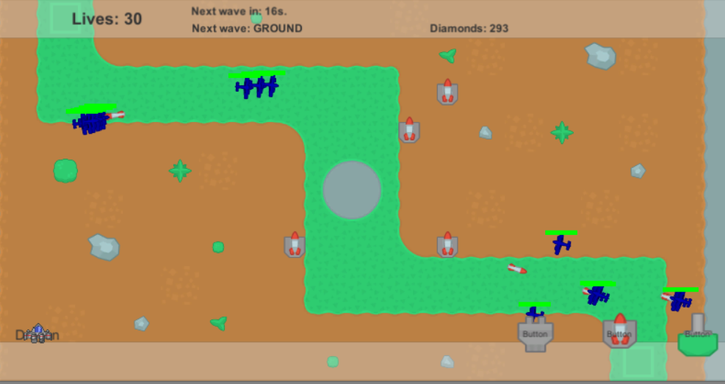

* **Anti-Air Tower**
* Scenario: Selected anti-air towers (and played around with the projectile speed and damage) and dragged them on the map while enemies spawned.
* Result(**EXPECTED**): The towers shoot projectiles only into „Flying” enemies, and damages them.